**Upgrading to LPWA (Low-Power Wide Area Networks for IoT)**

Acclima designed the radios to be modular and are easily switched out. To remove a 3G radio and replace it with a LPWA radio:

You’ll need:

* Small wrench (8mm)
* Phillips screwdriver
* Small flathead screwdriver (optional)

1. Unscrew the nuts with the wrench and remove the washers from the antenna connectors. A small flathead screwdriver may help lift the washers off.

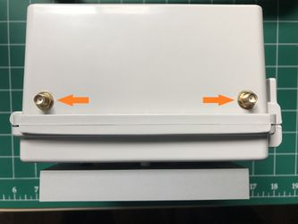

1. Remove the battery and set safely aside. Unplug the solar panel and unscrew the three screws holding the microcontroller card to the back of the enclosure.

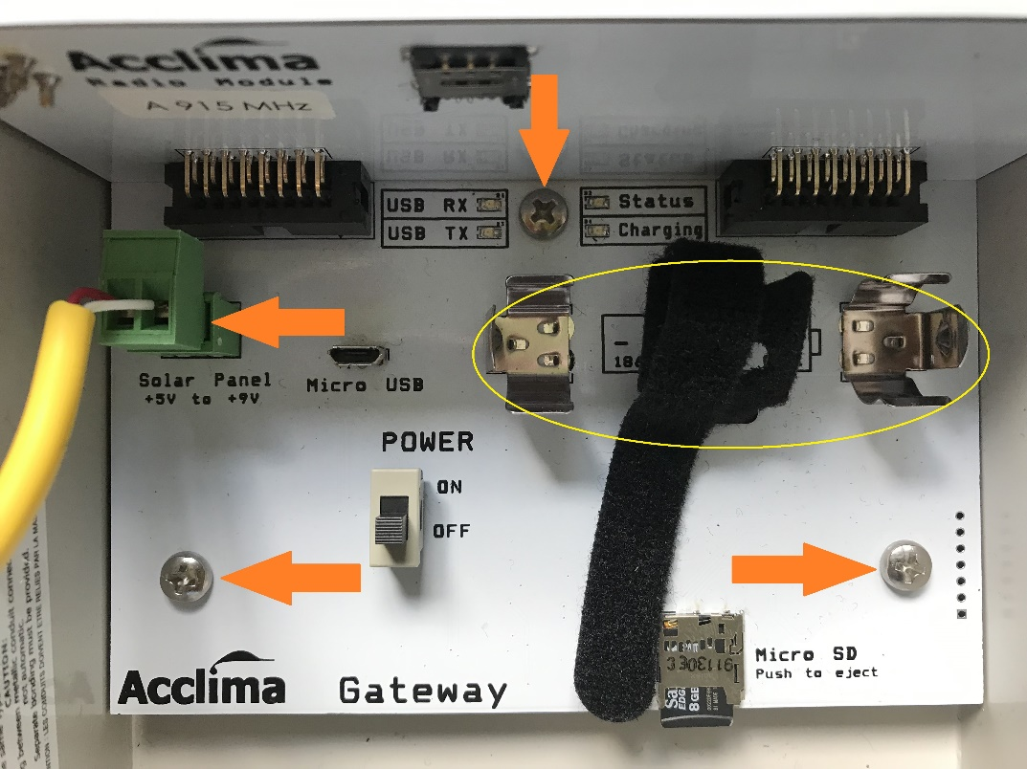

1. Push down on the antenna connectors to pull out the card assembly.

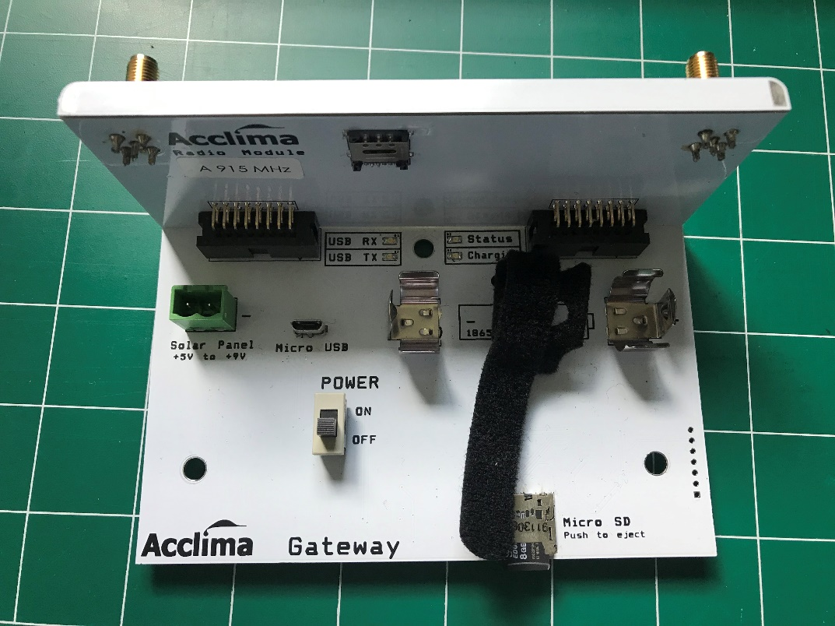

1. Pull the radio card apart from the microcontroller card.

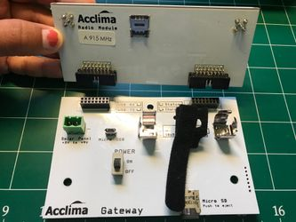

1. Connect the new radio card to the microcontroller card.

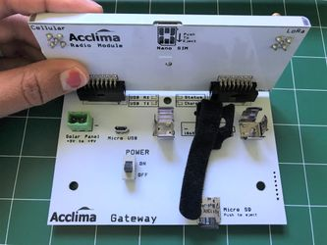

1. Replace the card assembly into the enclosure. Replace all screws and nuts. Reconnect the solar panel and battery.

